**Iteration 1:**

**y_train_pred =** [274.27 453.951 421.841 634.008 539.313 425.46 551.199 658.34 557.992

476.269 607.707 375.269 347.026 515.56 481.547 539.095 337.729 523.794

446.958 524.051 399.953 370.706 463.022 720.071 329.04 322.335 313.462

638.006 602.438 460.582 526.321 307.011 268.793 396.891 363.904 437.121

500.533 841.515 354.627 332.074 508.05 477.946 475.55 333.39 271.829

327.691 747.469 311.778 357.213 374.304 271.314 304.159 397.304 302.706

489.419 373.689 467.275 471.259 375.054 242.997 752.186 349.818 254.501

235.573 676.532 323.164 334.673 707.819 274.517 539.002 238.187 466.994

569.384 505.973 419.915 203.422 574.705 487.543 291.958 418.164 429.94

341.774 435.432 393.027 464.108 373.667 440.548 416.755 598.707 739.836

534.404 406.674 613.516 339.877 328.515 441.338 535.362 353.805 701.841

552.147 654.311 388.181 562.592 449.35 730.353 326.166 743.88 488.507

545.015 423.282 458.164 465.378 519.671 264.292 564.509 642.499 265.94 ]

**meanSE, medianSE, stdSE, spearmanR =** 54733.14907243712 9711.654551665411 136334.7911254007 0.8696096870397056

**y_val_pred =** [416.602 485.86 396.241 422.976 404.13 406.204 422.677 438.096 471.385

404.547 463.883 424.842 437.68 426.857 452.055 506.69 429.315 470.88

444.351 427.404 769.29 468.301 474.631 700.639 752.182 717.983 458.398

434.188]

**Confusion Matrix:**

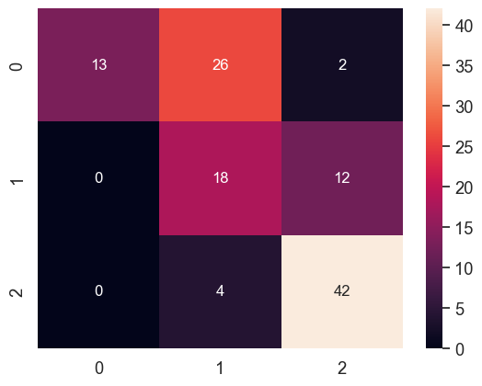

precision recall f1-score support

0 1.00 0.32 0.48 41

1 0.38 0.60 0.46 30

2 0.75 0.91 0.82 46

accuracy 0.62 117

macro avg 0.71 0.61 0.59 117

weighted avg 0.74 0.62 0.61 117

**Iteration 2:**

**y_train_pred =** [533.895 482.35 432.694 586.381 321.183 344.531 598.916 627.233 441.598

435.897 634.499 328.351 400.578 401.946 365.722 623.382 396.606 580.161

383.309 495.979 365.921 421.673 461.78 745.591 349.781 399.363 292.584

548.002 511.791 442.666 496.143 312.613 234.967 524.048 365.532 424.524

519.96 800.677 392.477 300.25 471.278 414.311 397.783 355.482 223.707

422.811 795.058 391.915 557.384 265.969 282.845 222.306 536.856 268.178

504.066 417.341 532.918 450.647 297.302 265.828 829.286 432.049 292.726

207.181 696.324 435.075 398.001 808.553 306.959 441.596 281.672 416.393

601.66 536.733 480.731 294.027 512.625 520.208 316.395 442.583 427.643

325.939 450.742 434.035 486.478 446.81 370.286 417.419 587.983 737.959

638.77 420.805 714.474 366.306 240.337 430.349 451.632 345.38 582.119

498.39 645.401 449.495 537.06 204.567 720.638 309.267 719.881 359.576

600.685 421.774 484.01 567.44 506.972 242.055 551.252 465.693 270.521]

**meanSE, medianSE, stdSE, spearmanR** = 56213.99174307014 17862.42166825139 128109.02172782169 0.8151314655885709

**y_val_pred** = [550.354 648.791 587.064 568.185 572.138 497.398 558.878 618.382 480.024

502.756 570.436 500.4 507.52 456.904 557.789 367.515 537.8 338.238

315.918 324.562 557.891 556.353 360.306 463.303 548.033 529.354 356.283

324.215]

**Confusion Matrix:**

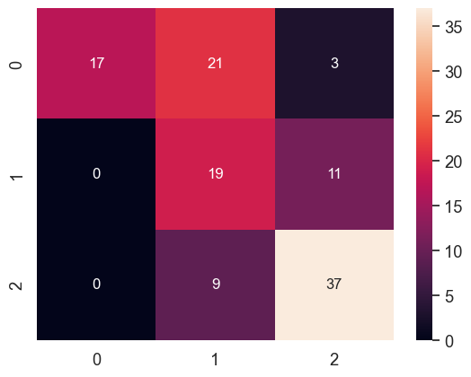

precision recall f1-score support

0 1.00 0.41 0.59 41

1 0.39 0.63 0.48 30

2 0.73 0.80 0.76 46

accuracy 0.62 117

macro avg 0.70 0.62 0.61 117

weighted avg 0.74 0.62 0.63 117

**Iteration 3**:

**y_train_pred** = [338.43 536.793 481.314 640.844 460.593 392.845 539.167 687.96 525.135

495.756 545.024 496.149 339.706 426.423 458.17 419.705 304.216 541.865

337.914 327.448 380.026 292.569 523.638 794.123 332.912 329.853 230.542

522.213 605.962 472.003 465.039 308.171 248.712 364.669 364.053 475.097

479.717 812.417 393.736 314.795 599.461 552.155 488.457 266.131 436.523

481.136 872.339 348.592 312.526 367.174 316.006 215.527 488.418 319.738

420.931 487.027 501.49 434.683 397.153 386.967 748.002 345.998 198.776

243.688 767.857 365.205 386.486 723.654 274.494 474.073 263.957 515.814

488.96 400.432 353.856 283.811 583.75 563.754 293.985 408.04 433.348

305.819 579.195 345.878 601.778 377.341 367.154 434.624 540.695 767.98

585.422 438.677 506.357 319.79 369.373 345.064 655.893 463.677 612.698

452.444 754.603 372.123 701.751 284.99 786.103 349.905 657.974 367.428

510.615 435.177 467.051 494.272 622.73 277.388 588.956 370.09 397.172]

**meanSE, medianSE, stdSE, spearmanR** = 49849.82812581206 11220.452761628874 119278.32781709713 0.8810216024884477

**y_val_pred** = [654.125 685.265 678.64 654.748 655.228 681.602 702.284 667.369 647.612

706.057 679.353 715.04 672.3 714.414 656.562 605.271 720.247 652.635

715.202 724.345 500.736 718.068 682.828 515.446 486.06 462.889 698.502

678.914]

**Confusion Matrix**:

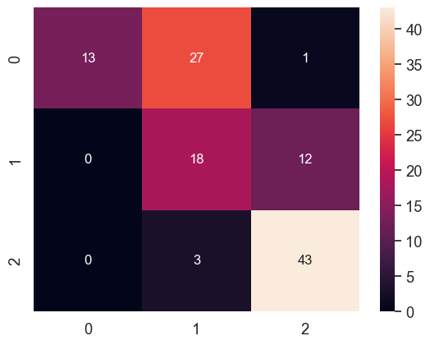

precision recall f1-score support

0 1.00 0.32 0.48 41

1 0.38 0.60 0.46 30

2 0.77 0.93 0.84 46

accuracy 0.63 117

macro avg 0.71 0.62 0.60 117

weighted avg 0.75 0.63 0.62 117

**Iteration 4**:

**y_train_pred** = [594.257 686.107 642.573 619.544 452.889 371.495 496.172 762.32 549.943

491.977 643.152 318.454 279.175 375.79 421.385 555.518 347.888 657.55

395.502 367.342 372.286 412.547 382.438 713.074 291.423 387.713 301.81

503.258 628.243 465.154 551.909 411.309 296.714 616.394 282.767 590.281

471.142 864.147 431.73 217.539 574.302 415.689 636.617 330.916 287.079

364.398 723.944 317.977 319.155 325.97 450.916 301.175 525.712 290.245

459.834 493.681 473.263 494.457 299.3 321.121 834.245 394.929 260.805

219.671 672.329 346.007 411.802 595.704 256.133 490.72 270.263 489.41

539.658 460.206 333.674 358.185 492.913 514.526 450.009 538.142 494.917

414.055 488.593 332.87 643.143 502.605 406.112 401.615 586.959 751.489

365.886 349.545 695.539 348.658 282.082 365.721 515.381 388.227 670.723

450.821 564.192 329.833 483.325 443.281 613.961 449.326 552.915 451.781

392.301 364.253 319.477 440.127 477.019 349.638 490.035 419.114 292.333]

**meanSE, medianSE, stdSE, spearmanR** = 59545.66853444236 13137.591676588847 140046.69377682105 0.8417130611594258

**y_val_pred** = [503.566 458.894 444.431 384.955 520.017 343.814 623.218 631.204 393.099

649.348 531.124 658.295 542.617 452.703 408.749 529.37 452.172 474.213

378.01 292.636 549.742 376.775 446.47 555.389 549.742 549.742 510.53

451.118]

**Confusion Matrix**:

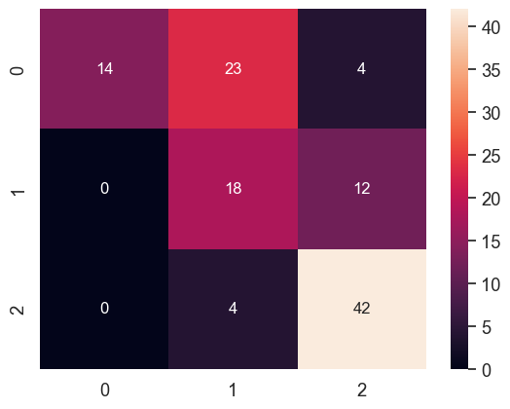

precision recall f1-score support

0 1.00 0.34 0.51 41

1 0.40 0.60 0.48 30

2 0.72 0.91 0.81 46

accuracy 0.63 117

macro avg 0.71 0.62 0.60 117

weighted avg 0.74 0.63 0.62 117

**Iteration 5**:

**y_train_pred** = [459.493 513.488 579.823 587.659 501.496 389.123 458.499 625.821 487.788

432.335 592.061 408.868 322.995 386.863 404.413 418.72 317.867 629.096

334.78 455.072 368.129 430.4 516.788 720.457 309.25 316.914 242.177

564.31 471.978 556.103 494.862 357.249 326.293 489.71 276.75 524.379

514.37 787.204 404.466 267.757 551.004 496.142 515.421 413.703 285.796

419.863 734.076 303.368 343.278 322.928 374.791 270.399 469.319 304.008

433.207 363.828 525.447 399.431 325.19 265.99 778.939 428.36 270.189

262.531 712.673 317.36 260.139 701.142 256.87 499.839 231.504 481.245

560.407 496.362 368.02 299.914 593.217 629.795 332.514 535.294 449.984

384.258 517.443 360.396 618.793 343.761 397.804 492.407 578.872 754.366

417.612 332.993 642.744 317.505 357.442 383.956 593.165 469.024 698.774

480.761 517.613 296.146 471.351 423.411 780.23 366.148 693.337 521.05

422.333 344.738 384.735 457.202 480.762 383.82 523.67 538.375 277.4 ]

**meanSE, medianSE, stdSE, spearmanR** = 54568.30699234045 12366.903981358488 139998.65523355757 0.9044336378263296

**y_val_pred** = [573.247 572.32 515.52 454.828 599.486 452.197 581.278 599.278 480.821

599.928 503.572 594.905 510.495 445.285 373.075 549.849 592.533 470.816

494.218 566.406 684.783 471.323 394.392 514.505 664.142 603.181 647.437

587.235]

**Confusion Matrix**:

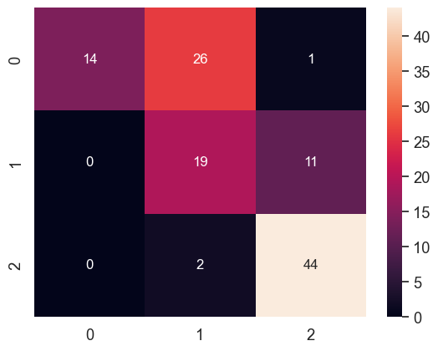

precision recall f1-score support

0 1.00 0.34 0.51 41

1 0.40 0.63 0.49 30

2 0.79 0.96 0.86 46

accuracy 0.66 117

macro avg 0.73 0.64 0.62 117

weighted avg 0.76 0.66 0.64 117

**Iteration 6**:

**y_train_pred** = [ 314.13 630.22 451.755 610.25 445.58 290.49 469.64 1213.585 492.78 483.33 578.86 383.26 242.42 373.185 398.195 452.385

326.45 532.065 359.175 418.68 372.395 333.215 420.745 1088.03

195.39 240.79 202.395 672.41 563.53 493.345 517.64 277.51

263.805 345.15 499.51 414.64 528.07 1203.435 404.445 151.435

522.265 588.59 444.025 329.4 227.345 359.75 1531.455 283.005

352.885 234.49 237.32 218.5 404.99 185.61 449.54 394.115

601.705 340.29 300.175 247.05 1045.845 364.57 173.625 154.1

894.605 307.795 375.375 886.91 233.555 500.87 188.275 416.85

400.21 476.99 365.28 212.23 518.93 476.52 265.89 473.655

413.405 267.355 424.975 355.615 582.4 337.635 336.735 497.355

607.74 985.15 451.145 258.935 611.69 225.845 246.515 378.34

554.175 370.775 620.36 511.19 829.235 374.585 541.78 196.93

1032.755 258. 774.065 405.225 344.385 285.98 374.755 522.51

472.875 259.37 595.565 532.645 233.41 ]

**meanSE, medianSE, stdSE, spearmanR** = 17104.483544444447 5390.496399999998 35541.669596029446 0.9542249563797703

**y_val_pred** = [1177.15 1174.38 815.215 533.005 1130.905 551.69 560.755 525.445 532.46 582.49 1308.465 497.835 604.855 765.7 1184.97 588.295

428.795 578.11 612.945 698.67 614.455 516.105 487.27 871.525

773.94 333.225 379.72 374.775]

**Confusion Matrix**:

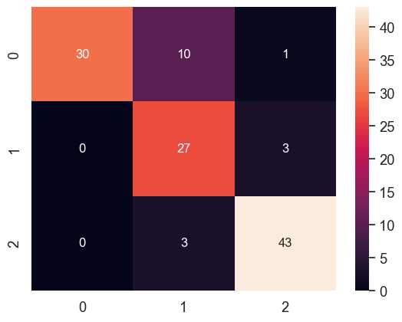

precision recall f1-score support

0 1.00 0.73 0.85 41

1 0.68 0.90 0.77 30

2 0.91 0.93 0.92 46

accuracy 0.85 117

macro avg 0.86 0.86 0.85 117

weighted avg 0.88 0.85 0.86 117

**Iteration 7**:

**y_train_pred** = [677.703 739.694 541.826 557.402 417.291 355.797 438.644 615.015 480.616

446.894 659.662 357.702 289.251 341.513 340.388 544.723 332.433 525.579

365.209 264.378 353.944 384.132 395.449 699.972 296.849 389.679 239.7

455.216 594.465 602.075 443.676 414.015 287.28 615.341 529.221 510.393

628.772 837.459 567.737 229.32 532.192 435.895 693.312 279.735 275.97

354.893 806.872 321.627 378.031 281.322 307.315 264.83 477.402 325.891

457.683 433.984 443.611 362.915 262.125 353.131 826.935 437.702 259.691

233.163 662.186 333.975 321.624 726.085 341.44 445.314 319.847 514.116

405.816 425.962 374.522 279.619 514.091 490.297 305.915 522.257 426.318

421.659 579.935 371.173 681.383 481.17 376.009 372.6 533.779 746.594

438.155 376.325 647.894 258.329 360.253 396.421 536.486 435.987 506.943

452.03 661.397 297.347 508.75 351.465 732.7 449.636 646.411 414.605

342.635 391.874 285.624 392.77 522.972 355.97 603.89 577.355 519.79 ]

**meanSE, medianSE, stdSE, spearmanR** = 57736.81802181111 15300.281782495662 127275.22429022608 0.8178102310336958

**y_val_pred** = [545.156 510.787 529.777 557.695 550.991 502.07 605.542 620.181 512.257

601.955 556.92 799.75 589.882 559.05 569.235 399.731 329.938 360.097

323.916 283.255 459.209 310.929 518.591 610.954 622.687 620.74 541.253

508.396]

**Confusion Matrix**:

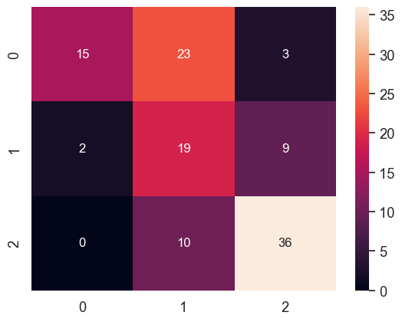

precision recall f1-score support

0 0.88 0.37 0.52 41

1 0.37 0.63 0.46 30

2 0.75 0.78 0.77 46

accuracy 0.60 117

macro avg 0.67 0.59 0.58 117

weighted avg 0.70 0.60 0.60 117

**Iteration 8**:

**y_train_pred** = [777.843 654.114 600.034 542.265 445.569 360.355 503.037 652.781 508.156

366.907 598.087 320.729 276.489 370.034 397.728 556.494 345.998 548.414

403.499 367.28 312.883 329.364 410.538 653.487 363.722 395.495 315.779

544.265 553.041 617.606 509.464 370.784 264.303 668.699 488.847 549.512

487.056 804.369 562.719 235.075 525.414 382.317 728.299 313.017 263.408

363.353 826.353 297.159 306.611 236.675 313.473 250.778 486.91 284.714

535.99 402.595 499.844 425.554 293.573 363.43 829.55 501.964 242.271

258.164 624.983 408.521 302.954 765.827 350.671 470.88 351.528 570.445

456.725 491.899 329.451 269.855 505.729 490.327 438.921 628.26 345.157

480.882 543.731 316.888 673.912 393.652 391.941 487.074 574.811 727.932

441.522 393.495 671.561 353.996 283.799 366.485 600.232 366.905 530.384

512.169 561.566 317.193 510.57 402.425 750.592 436.282 540.873 513.152

372.729 425.345 379.872 395.903 484.98 396.943 551.169 468.4 300.486]

**meanSE, medianSE, stdSE, spearmanR** = 61094.583280187384 15049.256543805663 131531.03634201238 0.8094030287136115

**y_val_pred** = [462.134 428.33 452.861 351.159 385.679 388.202 526.375 547.622 397.221

535.327 421.684 799.731 480.8 401.692 372.259 534.959 446.34 419.682

371.263 310.271 503.9 476.344 442.637 481.784 478.367 514.126 448.494

411.471]

**Confusion Matrix**:

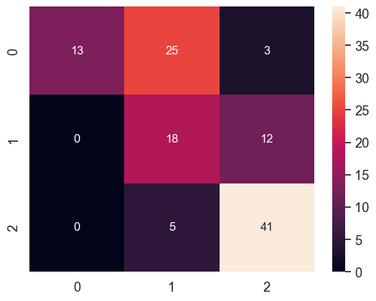

precision recall f1-score support

0 1.00 0.32 0.48 41

1 0.38 0.60 0.46 30

2 0.73 0.89 0.80 46

accuracy 0.62 117

macro avg 0.70 0.60 0.58 117

weighted avg 0.73 0.62 0.60 117

**Iteration 9**:

**y_train_pred** = [355.645 606.049 443.456 492.712 424.322 290.905 502.505 794.472 483.603

445.55 484.292 379.189 260.296 326.036 383.066 444.546 278.723 514.286

342.576 377.982 345.775 452.497 408.297 874.469 259.178 290.208 284.652

606.793 790.294 468.497 427.868 388.539 319.09 416.413 414.948 370.256

537.859 811.253 393.936 229.353 495.872 471.989 475.484 279.104 251.143

377.98 866.752 251.186 454.16 258.309 261.411 289.34 401.153 296.851

465.032 414.575 577.586 423.452 445.477 544.119 858.234 367.637 329.524

265.522 705.64 321.816 312.34 793.749 262.171 476.121 234.842 509.391

453.545 505.564 355.675 238.475 653.727 484.326 234.355 513.264 409.897

333.982 503.203 388.77 528.943 475.432 414.762 558.703 509.105 634.241

495.192 435.305 608.049 496.504 493.295 338.828 616.9 398.473 569.567

433.668 551.692 351.782 595.864 252.327 920.594 313.076 589.743 500.403

474.021 288.85 380.601 555.584 624.402 437.954 643.94 462.474 268.568]

**meanSE, medianSE, stdSE, spearmanR** 51527.233068118694 8832.619826673668 122295.51451008336 0.8269817244737877

**y_val_pred** = [638.335 631.622 618.264 639.376 596.534 647.217 605.589 595.815 580.908

529.612 648.542 590.075 609.595 647.521 619.558 598.192 599.206 628.385

554.143 583.444 792.547 536.627 498.218 569.629 557.745 571.569 599.744

559.086]

**Confusion Matrix**:

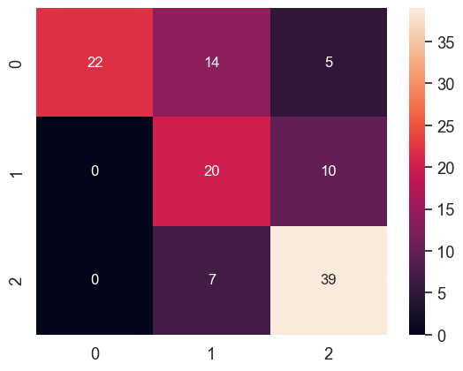

precision recall f1-score support

0 1.00 0.54 0.70 41

1 0.49 0.67 0.56 30

2 0.72 0.85 0.78 46

accuracy 0.69 117

macro avg 0.74 0.68 0.68 117

weighted avg 0.76 0.69 0.70 117

**Iteration 10**:

**y_train_pred** = [510.571 658.272 492.64 573.534 423.594 410.454 551.725 744.111 510.554

456.312 514.539 397.014 289.565 394.471 469.131 503.758 295.971 527.724

340.513 466.055 379.928 348.317 448.862 771.16 259.256 346.064 280.311

653.778 641.037 514.078 497.34 331.194 280.195 443.994 369.557 512.644

481.455 843.737 460.241 211.166 506.021 472.246 595.758 251.843 247.766

393.134 885.376 232.385 452.411 226.454 308.98 296.166 392.717 291.817

540.322 364.719 625.487 400.037 416.021 449.106 770.843 477.239 190.498

264.843 719.023 325.901 304.847 732.163 306.515 418.075 244.834 448.43

538.203 513.294 345.804 298.409 547.685 623.946 242.732 433.91 395.628

273.192 555.476 341.657 606.008 412.24 374.258 542.861 540.955 685.987

481.573 355.237 544.685 389.306 432.328 380.134 601.589 373.866 590.984

480.623 619.179 335.46 575.264 241.627 853.752 431.087 698.467 467.168

492.453 361.714 392.662 553.482 449.261 402.576 583.907 445.104 315.749]

**meanSE, medianSE, stdSE, spearmanR** = 49378.58224241513 11571.926921949971 118345.69942806555 0.8892489716038243

**y_val_pred** = [486.188 462.178 444.65 481.071 513.735 464.78 541.886 476.087 505.121

606.151 430.514 580.193 573.746 496.002 524.171 542.639 508.149 538.723

556.477 554.682 722.612 485.581 507.588 594.473 615.663 627.219 573.142

536.945]

**Confusion Matrix**:

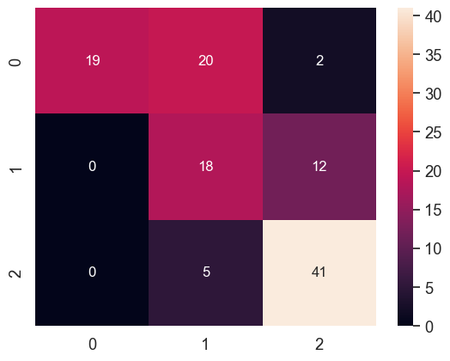

precision recall f1-score support

0 1.00 0.46 0.63 41

1 0.42 0.60 0.49 30

2 0.75 0.89 0.81 46

accuracy 0.67 117

macro avg 0.72 0.65 0.65 117

weighted avg 0.75 0.67 0.67 117